Budget Rent A Car 
of British Columbia

Global Information System

Vehicle Support & Contract Search Business Design

Version 2.00

Note: The information contained in this document is confidential and may not be disclosed to any parties outside of Budget Rent a Car of British Columbia without written consent by one of its officers.
Copyright (C) 2000 Budget Rent a Car of British Columbia
Table of Contents
1. Functional Area Business Design 1
1.1. Contracts 1
1.1.1. Process Description 1
1.1.2. Screens 2
1.1.2.1. Vehicle Support Incident Screen 2
1.1.2.1.1. Details Tab 13
1.1.2.1.2. Comments Tab 26
1.1.2.1.3. POs and Charges Tab 28
1.1.2.1.4. Compensation Tab 33
1.1.2.1.5. Check In Tab 38
1.1.2.2. Vehicle Support Incident Search Screen 41
1.1.2.3. Contract Search Screen 45
1.1.2.4. Vehicle on Contract Search Screen 50
1.1.3. Reports 53
1.1.4. All the vehicle support reports are defined in the GIS Reports business design documents.Tables without Maintenance Screens 53
1.1.4. Tables without Maintenance Screens 54
1.1.5. Data Model 55
2. Revision History 56
2.1. Version 2.00 56

Functional Area Business Design

Contracts

Process Description

Screens

Vehicle Support Incident Screen
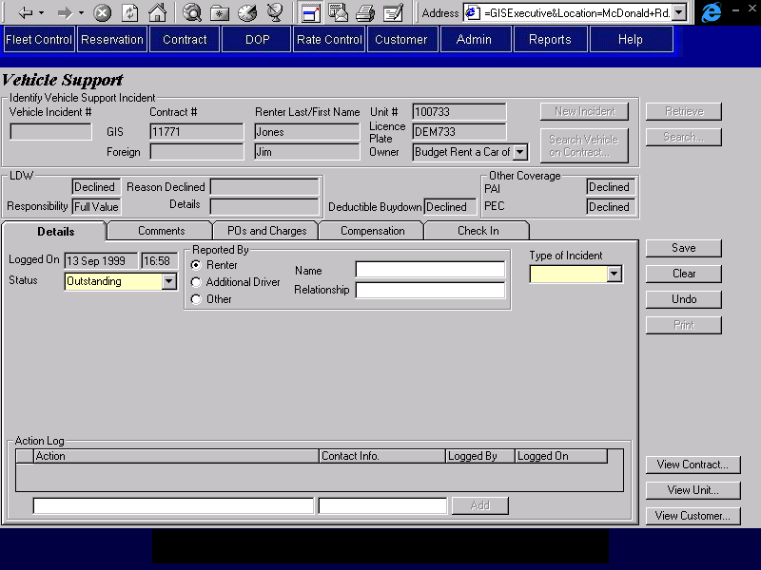

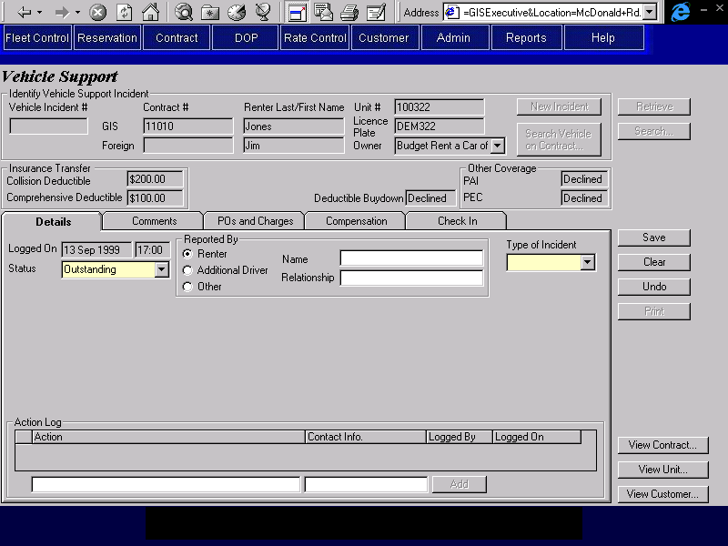
Purpose
The Vehicle Support screen is used for recording and resolving vehicle support incidents. Vehicle support incidents are initiated when DOP is contacted because a vehicle that is away from a Budget location (either on rent or in transit) has a mechanical problem, or is damaged, stolen or seized by law enforcement authorities.
The screen is organized into six areas: the base screen and five tabs. The base screen displays the information required to retrieve an existing incident or log a new incident. The tabs contain the remaining vehicle support incident information and are categorized as follows:
Details: Where the type and details of the incident are entered and where the actions taken to resolve the incident are logged.
Comments: Where the comments about the incident can be viewed and logged.
POS and Charges: Where purchase orders issued as a result of the incident can be logged and where manual charges relating to the incident can be added to the contract.
Compensation: Where discounts and reimbursements can be applied to the contract. These are intended to compensate the renter for any expense or inconvenience caused by the incident.
Check In: Where the vehicle can be checked in on its current contract. This will only be used when the check in is not taking place at a Budget BC location. The details of the check in will be visible through the Contract Check In screen, but cannot be changed from there.
Save, Clear, Undo and Print buttons are available at the right hand side of the screen.
Logging a New Incident
A new vehicle support incident can only be logged for a vehicle that is currently checked out on a contract or in transit. In order to log a new incident for a contract on GIS or for a vehicle movement, the user will have to enter one or more of the fields in the Identify Vehicle Support Incident section of the screen and press the New Incident button.
The fields entered in Identify Vehicle Support Incident will be used to log a new incident under the following conditions:
- GIS Contract #
The contract # exists on GIS and a vehicle is currently checked out on the contract.
- Foreign Contract #
A new incident will be logged whether the foreign contract # exists on GIS or not. If the foreign contract # exists on GIS and a vehicle is currently checked out, an incident will be created for that contract. Otherwise, it will be assumed that the contract does not exist on GIS (and that the existence of the same foreign contract # on GIS is a coincidence). In that case, the user will also have to enter all the fields on the Identify Vehicle Support Incident section of the screen.
- Renter Last Name and First Name
The Renter Last Name and First Name are an exact match for the renter last name and first name on one and only one open contract on GIS and a vehicle is currently checked out on the contract. If the renter has more than one open contract the user will have to specify the unit number or licence plate.
- Unit # and Vehicle Owner
The unit #/owner combination exists on GIS and the vehicle is currently checked out on a contract or in transit.
- Licence Plate and Vehicle Owner
The licence plate exists on GIS as the current licence plate for a vehicle with that vehicle owner and the vehicle is currently checked out on a contract or in transit.
When a new vehicle support incident is opened, GIS will log the date and time that the incident is recorded. If the incident is being logged for a contract, the coverages that apply to the contract will be displayed below the Identify Vehicle Support Incident section.
When the incident is saved, GIS will assign a unique sequence number to the incident.
Screen Hierarchy
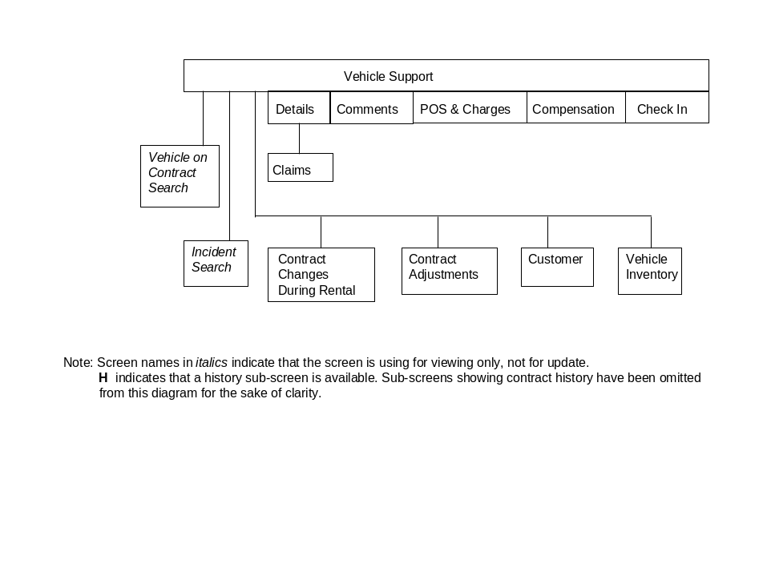
Navigation
Search: Opens the Vehicle Support Incident Search screen, populated with the fields entered in the Identify Vehicle Support Incident section and the search results for those fields. Once a vehicle support incident is selected in the search screen, the search screen will be closed and the Vehicle Support Incident screen will be populated with the information for that incident. Enabled when the screen is first opened and after the Clear button has been used. Disabled after the Vehicle Support Incident screen has been populated with an existing vehicle support incident using the Retrieve or Search buttons or when a new incident has been logged using the New Incident or Search Vehicle on Contract buttons.
Search Vehicle Opens the Vehicle On Contract Search screen, populated with the fields
On Contract: entered in the Identify Vehicle Support Incident section and the search results for those fields. If a Vehicle On Contract that is currently checked out is selected, the Vehicle On Contract Search screen will be closed and a new vehicle support incident will be logged for the Vehicle On Contract selected. Enabled when the screen is first opened and after the Clear button has been used. Disabled after the Vehicle Support Incident screen has been populated with an existing vehicle support incident using the Retrieve or Search buttons or when a new incident has been logged using the New Incident or Search Vehicle on Contract buttons.
View Contract: Opens the Contract Changes During Rental or Contract Adjustments screen for Contract #, depending on whether the contract is still checked out, or has been through final check in. Whether the screens are view only or not will depend on the security access of the user.
View Unit: Opens the Vehicle Inventory screen for the Unit # or Licence Plate and the Vehicle Owner. Whether the screen is view only or not will depend on the security access of the user. Disabled when the screen is opened from Contract Open/Check Out, Changes During Rental or Check In.
View Customer: If a specific vehicle on contract has been retrieved and the contract is linked to a customer, opens the Customer screen for the customer linked to the current contract. Otherwise opens the Customer Search screen, pre-populated with the renter name and the search results for the name. Whether the screen is view only or not will depend on the security access of the user.
Functions
New Incident: See the description for ‘Logging a New Incident’ above. Enabled when the screen is first opened and after the Clear button has been used. Disabled after the Vehicle Support Incident screen has been populated with an existing vehicle support incident using the Retrieve or Search buttons or when a new incident has been logged using the New Incident or Search Vehicle on Contract buttons.
Retrieve: If a Sequence is entered, the screen will be populated with the information for that incident. Otherwise, the Vehicle Support Incident Search screen will be opened, populated with the fields entered in Identify Vehicle Support Incident and the search results for those fields. Once a vehicle support incident is selected in the search screen, the search screen will be closed and the Vehicle Support Incident screen will be populated with the information for that incident. Enabled when the screen is first opened and after the Clear button has been used. Disabled after the Vehicle Support Incident screen has been populated with an existing vehicle support incident using the Retrieve or Search buttons or when a new incident has been logged using the New Incident or Search Vehicle on Contract buttons.
Print: Prints a report on the current vehicle support incident. Disabled unless a new or existing vehicle support incident is displayed on the screen.
Controls
Req*: Y – always mandatory
N – always optional
S – sometime optional (see Comments for details)
D – display only
Field | Source | Req* | Validation | Comments
Identify Vehicle Support Incident
Vehicle Incident # | Vehicle Support Incident, Vehicle Support Incident Sequence | Y |  | Assigned by GIS when a new incident is saved.  Locked when an existing incident is retrieved.
GIS Contract # | Vehicle Support Incident, Contract Number | S |  | Required if the incident is for a Vehicle On Contract, locked if the incident is for a movement.  Populated from the Vehicle on Contract for a new incident (may be entered by user if Foreign Contract is Yes).
Foreign Contract # | Vehicle Support Incident, Foreign Contract Number | N |  | Required if the incident is for a non-Budget BC contract, locked if the incident is for a movement.
Renter Last Name | Vehicle Support Incident, Last Name | S |  | Required if the incident is for a Vehicle On Contract or a foreign contract that does not exist on GIS, locked if the incident is for a movement.  Populated from the Vehicle on Contract for a new incident (may be entered by user if Foreign Contract is Yes).
First Name | Vehicle Support Incident, First Name | S |  | Required if the incident is for a Vehicle On Contract or a foreign contract that does not exist on GIS, locked if the incident is for a movement.  Populated from the Vehicle on Contract for a new incident (may be entered by user if Foreign Contract is Yes).
Unit # | Vehicle Support Incident, Unit Number | Y |  | Populated from the Vehicle on Contract for a new incident (may be entered by user if Foreign Contract is Yes).
Licence Plate | Vehicle Support Incident, Licence Plate | Y |  | Populated from the Vehicle on Contract for a new incident (may be entered by user if Foreign Contract is Yes).
Owner | Vehicle Support Incident, Owning Company | Y |  | Default is BRAC (when Unit # or Licence Plate is entered).  Populated from the Vehicle on Contract for a new incident (may be entered by user if Foreign Contract is Yes).
Insurance Transfer |  |  |  | Only visible when the incident is logged for a vehicle on contract and the contract has an insurance transfer with both collision and comprehensive coverage.
Collision Deductible | Insurance Transfer, Collision Deductible | D
Comprehensive Deductible | Insurance Transfer, Comprehensive Deductible | D
Deductible Buydown | Contract Optional Extra, Optional Extra ID | D |  | ‘Accepted’ if there is an optional extra for the contract with type ‘Buydown’ and ‘Declined’ otherwise.
LDW |  |  |  | Only visible when the incident is logged for a vehicle on contract and when Insurance Transfer is not visible.
(LDW) | Contract Optional Extra, Optional Extra ID and Included In Rate | D |  | ‘Included’ if LDW is included in the rate, ‘Accepted’ if there is an optional extra for the contract with type ‘LDW’ and ‘Declined’ otherwise.
Responsibility | Contract Optional Extra, Optional Extra ID  LDW Deductible, LDW Deductible | D |  | If LDW is ‘Included ‘ or ‘Accepted’, use the LDW Deductible record for the contract vehicle class and the Contract Optional Extra with Type ‘LDW’.  ‘Full Value’ if LDW is ‘Declined’.
Reason Declined | Contract, LDW Declined Reason | D
Details | Contract, LDW Declined Details | D
Corporate Responsibility | Quoted Vehicle Rate, Corporate Responsibility | D |  | Bot the field and label are only visible when the contract has been opened from a reservation passed from Maestro, using the quoted rate and when there is a value in the Corporate Responsibility field for the quoted rate.
Deductible Buydown | Contract Optional Extra, Optional Extra ID | D |  | ‘Accepted’ if there is an optional extra for the contract with type ‘Buydown’ and ‘Declined’ otherwise.
Other Coverage |  |  |  | Only visible when the incident is logged for a vehicle on contract.
PAI | Contract Optional Extra, Optional Extra ID | D |  | ‘Included’ if PAI is included in the rate, ‘Accepted’ if there is an optional extra for the contract with type ‘PAI’ and ‘Declined’ otherwise.
PEC | Contract Optional Extra, Optional Extra ID | D |  | Only visible when the Optional Extra with type PEC is not restricted for the contract Vehicle Type.  ‘Included’ if PEC is included in the rate, ‘Accepted’ if there is an optional extra for the contract with type ‘PAI’ and ‘Declined’ otherwise.
Cargo Insurance | Contract Optional Extra, Optional Extra ID | D |  | Only visible when the Optional Extra with type Cargo Insurance is not restricted for the contract Vehicle Type.  ‘Included’ if Cargo Insurance is included in the rate, ‘Accepted’ if there is an optional extra for the contract with type ‘Cargo Insurance’ and ‘Declined’ otherwise.
Technical Notes
When saving a new vehicle support incident, set the sequence to the next available vehicle support incident sequence number.
When saving a new vehicle support incident for contract that exists on GIS, set the following fields on Vehicle Support Incident from the Vehicle on Contract that the incident is linked to:
- Contract #
- Renter Last Name (Contract)
- Renter First Name (Contract)
- Unit #
- Licence Plate (Vehicle)
- Vehicle Owner
- Model (Vehicle)
- Serial # (Vehicle)
- Exterior Colour (Vehicle)
When saving a new vehicle support incident for contract that does not exist on GIS, set the following fields on Vehicle Support Incident from the screen:
- Contract #
- Renter Last Name
- Renter First Name
- Unit #
- Licence Plate
- Vehicle Owner
- Model (if entered)
- Serial # (if entered)
- Exterior Colour (if entered)
When saving a new vehicle support incident for a movement, set the following fields on Vehicle Support Incident from the Movement that the incident is linked to:
- Unit #
- Licence Plate (Vehicle)
- Vehicle Owner
- Model (Vehicle)
- Serial # (Vehicle)
- Exterior Colour (Vehicle)

Details Tab
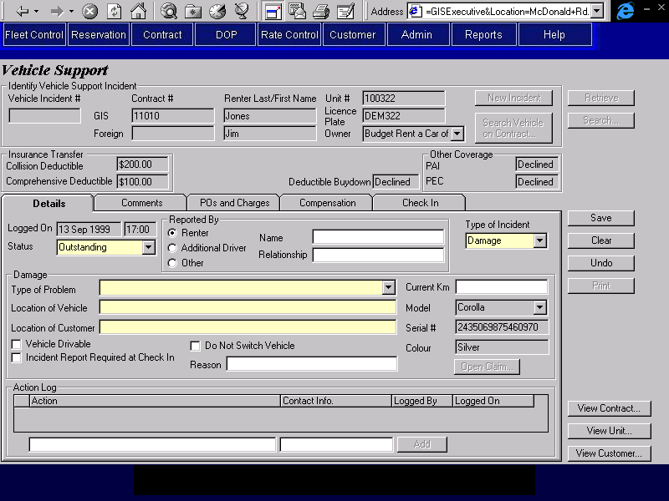

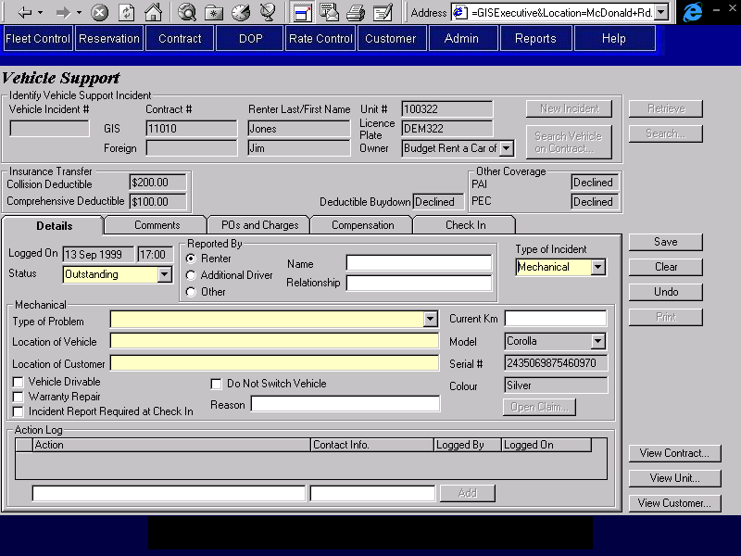

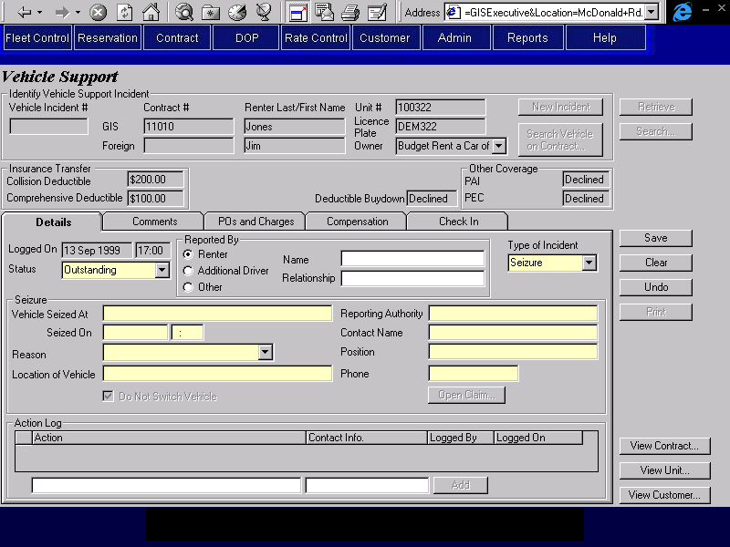

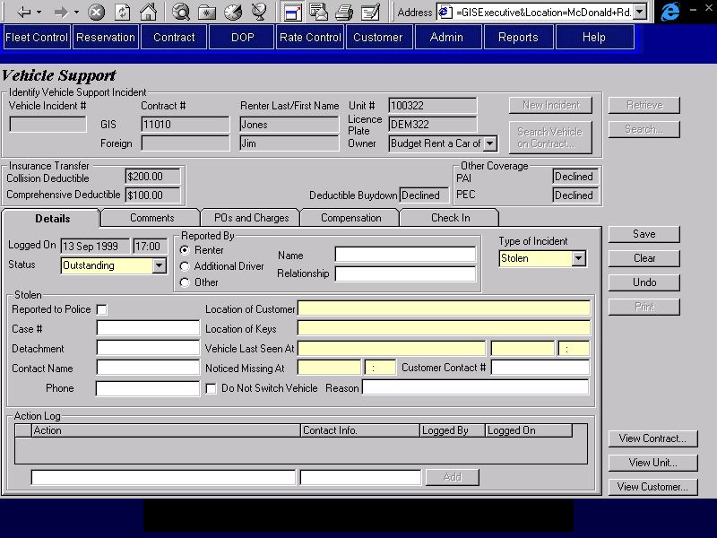
Purpose
The details tab allows the user to view and record the details of a vehicle support incident and to view and log the actions taken to resolve the incident.
When a new vehicle support incident is opened, the date and time are logged, and displayed on this tab. The status for a new incident defaults to “Outstanding” and can be updated by the user once the incident has been resolved.
When a new incident is opened, the user will first record who is reporting the incident; the renter, an additional driver or someone else. If it is not the renter, the name of the person will be recorded, and if it is not an additional driver, the person’s relationship to the incident will be recorded. Next, the user will record the type of incident: Mechanical, Damage, Stolen, or Seizure. Once the type of incident has been selected, the information to be recorded for that type of incident will be displayed and can be filled in.
At the bottom of the screen, there is an action log where the user can record the actions taken to resolve the incident.
Navigation
N/A
Functions
Add: Adds a new action to the action log.
Controls
Req*: Y – always mandatory
N – always optional
S – sometime optional (see Comments for details)
D – display only
Field | Source | Req* | Validation | Comments
Logged On | Vehicle Support Incident, Logged On | D |  | Date and time the incident was opened.
Status | Vehicle Support Incident, Status | Y | Selection only  Outstanding/  Resolved | Defaults to Outstanding
Reported By
Renter/  Additional Driver/  Other | Vehicle Support Incident, Reported By Role | Y |  | Defaults to Renter. Additional Driver will be disabled if the incident is being logged for a movement.
Name | Vehicle Support Incident, Reported By Name | S |  | Required if Reported By is not Renter
Relationship | Vehicle Support Incident, Reported By Relationship | S |  | Required if Reported By is Other
Type of Incident | Vehicle Support Incident, Incident Type | Y | Selection Only  Mechanical/  Damage/Stolen/  Seizure
Mechanical |  |  |  | Only visible when Type of Incident is Mechanical.
Type of Problem | Mechanical Incident, Type | Y | Selection Only  Value controlled by Mechanical Problem Type table.
Location of Vehicle | Mechanical Incident, Vehicle Location | Y
Location of Customer | Mechanical Incident, Customer Location | Y
Vehicle Drivable | Mechanical Incident, Vehicle Drivable | N
Warranty Repair | Mechanical Incident, Warranty Repair | N
Incident Report Required at Check In | Mechanical Incident, Incident Report Required at Check In | N
Do Not Switch Vehicle | Vehicle Support Incident, Do Not Switch Vehicle | N |  | Not visible if the incident is logged for a movement.
Reason | Vehicle Support Incident, Do Not Switch Reason | S |  | Not visible if the incident is logged for a movement.  Required if Do Not Switch Vehicle is Yes
Current Km | Mechanical Incident, Current Km | S | Numeric, whole number | Required if Warranty Repair is Yes.
Model | Mechanical Incident, Vehicle Model | S |  | Required if Warranty Repair is Yes.  Set from Vehicle on Contract and locked if incident is for a contract that exists on GIS. Set from Movement and locked if incident is for a movement.
Serial # | Mechanical Incident,  Vehicle Serial Number | S |  | Required if Warranty Repair is Yes.  Set from Vehicle on Contract and locked if incident is for a contract that exists on GIS. Set from Movement and locked if incident is for a movement.
Colour | Mechanical Incident, Vehicle Exterior Colour | S |  | Required if Warranty Repair is Yes.  Set from Vehicle on Contract and locked if incident is for a contract that exists on GIS. Set from Movement and locked if incident is for a movement.
Damage |  |  |  | Only visible when Type of Incident is Damage.
Type of Problem | Damage Incident, Type | Y | Selection Only  Value controlled by Damage Problem Type table.
Location of Vehicle | Damage Incident, Vehicle Location | Y
Location of Customer | Damage Incident, Customer Location | Y
Vehicle Drivable | Damage Incident, Vehicle Drivable | N
Incident Report Required at Check In | Damage Incident, Incident Report Required at Check In | N
Do Not Switch Vehicle | Vehicle Support Incident, Do Not Switch Vehicle | N |  | Not visible if the incident is logged for a movement.
Reason | Vehicle Support Incident, Do Not Switch Reason | S |  | Not visible if the incident is logged for a movement.  Required if Do Not Switch Vehicle is Yes
Current Km | Damage Incident, Current Km | N | Numeric, whole number
Model | Damage Incident, Vehicle Model | N |  | Set from Vehicle on Contract and locked if incident is for a contract that exists on GIS. Set from Movement and locked if incident is for a movement.
Serial # | Damage Incident, Vehicle Serial Number | N |  | Set from Vehicle on Contract and locked if incident is for a contract that exists on GIS. Set from Movement and locked if incident is for a movement.
Colour | Damage Incident, Vehicle Exterior Colour | N |  | Set from Vehicle on Contract and locked if incident is for a contract that exists on GIS. Set from Movement and locked if incident is for a movement.
Stolen |  |  |  | Only visible when Type of Incident is Stolen.
Reported to Police | Stolen Incident, Reported to Police | N
Case # | Stolen Incident, Case Number | S |  | Required if Reported to Police is Yes.
Detachment | Stolen Incident, Detachment | S |  | Required if Reported to Police is Yes.
Contact Name | Stolen Incident, Contact Name | S |  | Required if Reported to Police is Yes.
Contact Phone | Stolen Incident, Contact Phone | S |  | Required if Reported to Police is Yes.
Location of Customer | Stolen Incident, Customer Location | Y
Location of Keys | Stolen Incident, Key Location | Y
Vehicle Last Seen At (location) | Stolen Incident, Last Seen Location | Y
Vehicle Last Seen At (time) | Stolen Incident, Last Seen Time | Y | Date/Time
Noticed Missing At | Stolen Incident, Noticed Missing At | Y | Date/Time
Customer Contact # | Stolen Incident, Customer Contact Phone | N
Do Not Switch Vehicle | Vehicle Support Incident, Do Not Switch Vehicle | N |  | Not visible if the incident is logged for a movement.
Reason | Vehicle Support Incident, Do Not Switch Reason | S |  | Not visible if the incident is logged for a movement.  Required if Do Not Switch Vehicle is Yes
Seizure |  |  |  | Only visible when Type of Incident is Seizure.
Vehicle Seized At | Seizure Incident, Seizure Location | Y
Seized On | Seizure Incident, Seizure Time | Y | Date/Time
Reason | Seizure Incident, Reason | Y | Free form text or selected from Seizure Reason table.
Location of Vehicle | Seizure Incident, Vehicle Location | Y
Do Not Switch Vehicle | Vehicle Support Incident, Do Not Switch Vehicle | D |  | Not visible if the incident is logged for a movement, set to Yes and locked otherwise.
Reporting Authority | Seizure Incident, Reporting Authority | Y
Contact Name | Seizure Incident, Contact Name | Y
Contact Position | Seizure Incident, Contact Position | Y
Contact Phone | Seizure Incident, Contact Phone | Y
Action Log |  |  |  | Only visible when a specific vehicle on contract has been identified.
(action) | Vehicle Incident Action Log, Action | D
Contact Info. | Vehicle Incident Action Log, Contact Information | D
Logged By/On | Vehicle Incident Action Log, Logged By and Logged On | D
(action) | Vehicle Incident Action Log, Action | N
Contact Info. | Vehicle Incident Action Log, Contact Information | N
Technical Notes
Do Not Switch Vehicle Flag
If Vehicle Support Incident, Do Not Switch Vehicle is Yes when Save is pressed, set Contract, Do Not Switch Vehicle to Yes if the incident is being logged for a movement.
If Vehicle Support Incident, Do Not Switch Vehicle is No when Save is pressed and Contract, Do Not Switch Vehicle is Yes, check to see if there are any other Vehicle Support Incidents for the Contract where Do Not Switch Vehicle is Yes. If there aren’t any, set Contract, Do Not Switch Vehicle to No.

Comments Tab
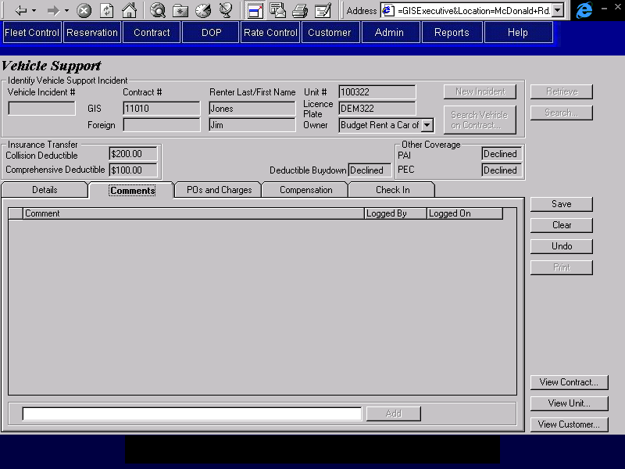
Purpose
The comments tab allows the user to view and record the comments about a vehicle support incident.
Navigation
N/A
Functions
Add: Adds a new comment to the vehicle support incident.
Controls
Req*: Y – always mandatory
N – always optional
S – sometime optional (see Comments for details)
D – display only
Field | Source | Req* | Validation | Comments
Comment | Vehicle Support Comments, Comments | D
Logged By/On | Vehicle Support Comments, Logged By and Logged On | D
Comment | Vehicle Support Comments, Comments | N

POs and Charges Tab
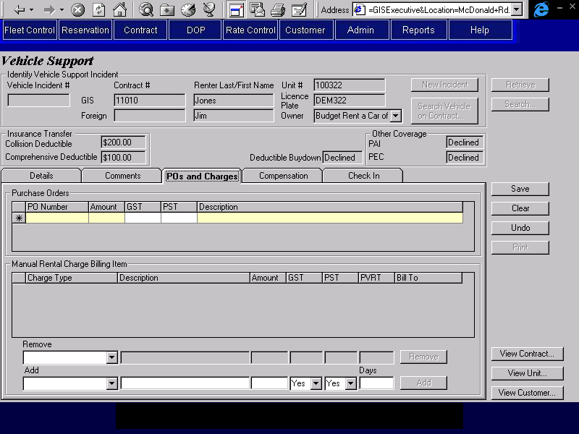
Purpose
The POs and Charges tab allows the user to view and record the purchase orders raised for a vehicle support incident and any charges to be added to the contract as a result of the incident. Charges cannot be entered through this screen after the vehicle has been checked in, the Contract Adjustments screen must be used instead.
Navigation
N/A
Functions
Add: Adds a new Manual Rental Charge Billing Item to the contract using the information entered.
Remove: Removes the selected Manual Charge Billing Item from the contract.
Controls
Req*: Y – always mandatory
N – always optional
S – sometime optional (see Comments for details)
D – display only
Field | Source | Req* | Validation | Comments
Purchase Orders
PO Number | Vehicle Support Purchase Order, PO Number | S |  | Required if any other fields on the line are present.
Amount | Vehicle Support Purchase Order, Amount | S | Currency | Required if PO Number is entered.
GST | Vehicle Support Purchase Order, GST | N | Currency
PST | Vehicle Support Purchase Order, PST | N | Currency
Description | Vehicle Support Purchase Order, Description | S |  | Required if PO Number is entered.
Manual Rental Charge Billing Item |  |  |  | Only display charge items entered for this incident (Contract Charge Item.Vehicle Support Incident Sequence equals the sequence for the current incident).
Charge Type | Contract Charge Item, Charge Type | D
Description | Contract Charge Item, Charge Description | D
Amount | Contract Charge Item, Amount | D
GST | Contract Charge Item, GST Amount | D
PST | Contract Charge Item, PST Amount | D
PVRT | Contract Charge Item, PVRT Amount | D
Bill To | Contract Charge Item, Contract Billing Party ID | D |  | If Contract Billing Party, Billing Type = Primary and Billing Method = Renter then display Renter.  If Contract Billing Party, Billing Type = Primary and Billing Method = Direct Bill then display Direct Bill.
Remove
Charge Type | Contract Charge Item, Charge Type | N | Selection controlled by existing list of manual charges.
Description | Contract Charge Item, Charge Description | D
Amount | Contract Charge Item, Amount | D
GST | Contract Charge Item, GST Amount | D
PST | Contract Charge Item, PST Amount | D
PVRT | Contract Charge Item, PVRT Amount | D
Add
Charge Type | Contract Charge Item, Charge Type | S | Value controlled by Charge Type table. | Required if adding a charge item.
Description | Contract Charge Item, Charge Description | S |  | Required if adding a charge item.
Amount | Contract Charge Item, Amount | S | Currency | Required if Charge Item is entered.
GST | Contract Charge Item, GST Amount or GST Exempt | Y | Selection only  Yes/  No | Default is Yes  Contract Manual Charge Item, GST Amount will be calculated using current GST rate if Yes is selected. If No is selected GST Exempt will be Yes.
PST | Contract Charge Item, PST Amount or PST Exempt | Y | Selection only  Yes/No | Default is Yes  Contract Manual Charge Item, PST will be calculated using current PST rate if Yes is selected. If No is selected PST Exempt will be Yes.
PVRT Days | Contract Charge Item, PVRT Amount and PVRT Days | N | Numeric, whole number. | Default is null  Contract Manual Charge Item, PVRT will be calculated using number of days entered times the current PVRT rate.
Technical Notes
When creating a new Contract Charge Item:
- set Charge Item Type to ‘Manual’
- set Billed To to the party authorizing the rental (the Contract Billing Party with Billing Type ‘Primary’)
- Set GST Included to No
- If GST is ‘No’ set GST Exempt to Yes, otherwise set it to No
- Set PST Included to No
- If PST is ‘No’ set PST Exempt to Yes, otherwise set it to No
- link the Contract Charge Item to the Vehicle Support Incident

Compensation Tab
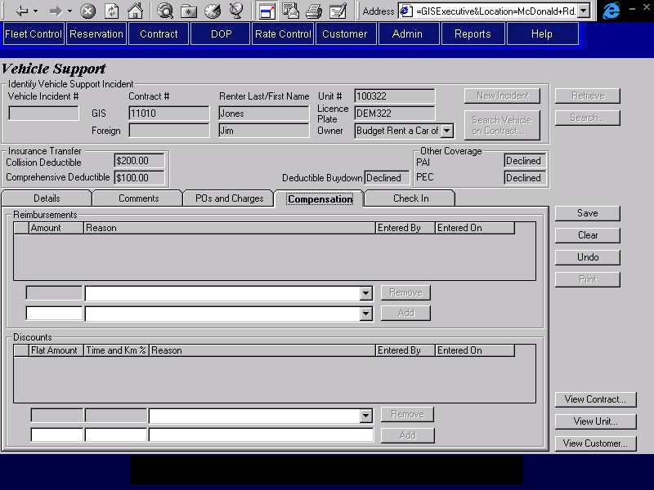
Purpose
The compensation tab allows the user to view and record any compensation to the renter that results from the vehicle support incident. Compensation can be given either as a direct reimbursement on the contract or as a discount applied to the contract charges. Only reimbursements and discounts that were recorded through this screen will display on this screen. Compensation cannot be entered through this screen after the vehicle has been checked in, the Contract Adjustments screen must be used instead.
If there are any reimbursements to be recorded, the user will enter the reimbursement amount and the reason.
Discounts can be an amount or a percentage. Percentage discounts are applied to the time and km charges only.
Any reimbursement or discount applied to the contract will be used to reduce the charges bill to the party authorizing the rental, not the charges billed to an alternate payment organization.
Navigation
N/A
Functions
Add (Reimbursement): Adds a new reimbursement to the contract.
Add (Discount): Adds a new discount to the contract.
Remove (Reimbursement): Removes the selected reimbursement from the contract.
Remove (Discount): Removes the selected discount from the contract.
Controls
Req*: Y – always mandatory
N – always optional
S – sometime optional (see Comments for details)
D – display only
Field | Source | Req* | Validation | Comments
Reimbursements |  |  |  | Only display reimbursements entered through this screen (Contract Reimbursement and Discount.Type = Reimbursement and Contract Reimbursement and Discount.Vehicle Support Incident Sequence equals the sequence for the current incident).
Amount | Contract Reimbursement and Discount, Flat Amount | D
Reason | Contract Reimbursement and Discount, Reimbursement Reason | D
Entered By | Contract Reimbursement and Discount, Entered By | D
Entered On | Contract Reimbursement and Discount, Entered On | D
Remove Reimbursement
Amount | Contract Reimbursement and Discount, Flat Amount | D
Reason | Contract Reimbursement and Discount, Reimbursement Reason | D | Selection controlled by list of reimbursements already added by this vehicle support incident.
Add Reimbursement
Amount | Contract Reimbursement and Discount, Flat Amount | S | Currency | Required if adding a reimbursement.
Reason | Contract Reimbursement and Discount, Reimbursement Reason | S | Value controlled by Reimbursement Reason table. | Required if adding a reimbursement.
Discount |  | D |  | Only display discounts entered through this screen (Contract Reimbursement and Discount.Type = Discount and Contract Reimbursement and Discount.Vehicle Support Incident Sequence equals the sequence for the current incident).
Flat Amount | Contract Reimbursement and Discount, Flat Amount | D
Time and Km % | Contract Reimbursement and Discount, Percentage | D
Reason | Contract Reimbursement and Discount, Discount Reason | D
Entered By | Contract Reimbursement and Discount, Entered By | D
Entered On | Contract Reimbursement and Discount Entered On | D
Remove Discount
Flat Amount | Contract Reimbursement and Discount, Flat Amount | D
Time and Km % | Contract Reimbursement and Discount, Percentage | D
Reason | Contract Reimbursement and Discount, Discount Reason | D | Selection controlled by list of discounts already added by this vehicle support incident.
Add Discount
Flat Amount | Contract Reimbursement and Discount, Flat Amount | S | Currency | Only one of Amount and % can be entered.  One of Amount and % required if discount added.
Time and Km % | Contract Reimbursement and Discount, Percentage | S | Must be <= 100 and greater than zero | Only one of Amount and % can be entered.  One of Amount and % required if discount added.
Reason | Contract Reimbursement and Discount, Discount Reason | S |  | Required if discount added.
Technical Notes
Adding Reimbursements and Discounts
When adding a reimbursement or discount, link the Contract Reimbursement and Discount to the Vehicle Support Incident.

Check In Tab
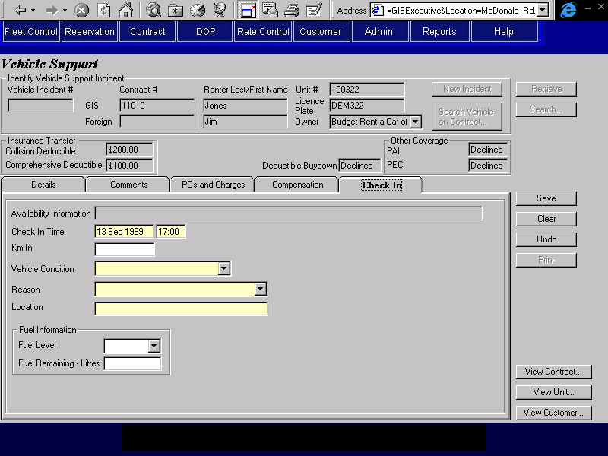
Purpose
The check in tab is used to check in the vehicle on its current contract. This will transfer the responsibility for the vehicle from the Renter to Budget. All optional extras that are currently rented will also be checked in or ended at the same time as the vehicle check in. This tab will only be used when the check in is not taking place at a Budget BC location.
The details of a check in entered on this tab will be visible through the Contract Check In screen, but cannot be changed from there (except for fuel and kilometre information).
This tab will be disabled unless the current vehicle on contract is checked out.
Navigation
N/A
Functions
N/A
Controls
Req*: Y – always mandatory
N – always optional
S – sometime optional (see Comments for details)
D – display only
Field | Source | Req* | Validation | Comments
Vehicle Information |  | D |  | Same as Availability Information in the Location Vehicle Availability screen. See notes on Populating the Vehicle Availability List in Location Vehicle Availability section.
Check In Time | Vehicle On Contract, Actual Check In | Y | Date and time | Defaults to current time.
Km In | Vehicle On Contract, Km In | N | Numeric
Vehicle Condition | Vehicle On Contract, Vehicle Condition | Y | Value controlled by Vehicle Condition table.
Reason | Vehicle On Contract, Vehicle Not Present Reason | Y | Value controlled by Vehicle Not Present Reason table.
Location | Vehicle On Contract, Vehicle Not Present Location | Y
Fuel Information |  |  |  | Only visible if FPO is blank or if a replacement has occurred after FPO was purchased.
Fuel Level | Vehicle On Contract, Fuel Level | N | Values are in 8ths or Full or Empty. | Only one of Fuel Level and Fuel Remaining can be entered.
Fuel Remaining – Litres | Vehicle On Contract, Litres of Fuel Remaining | N | Numeric | Only one of Fuel Level and Fuel Remaining can be entered.
Technical Notes
Do not update Vehicle On Contract or perform any other updates unless Condition Status has changed or either Reason or Location are entered.
When saving the updates to Vehicle On Contract, set Checked In By to User ID.
The Vehicle table must be updated with the values for the fields shown:
Current Km Km In
Current Rental Status ‘Available’
Rental Status Effective On Actual Check In
Current Condition Status Vehicle Condition
Condition Status Effective On Actual Check In (if Current Condition Status has changed)
If the Condition Status has changed a new condition status record for the vehicle must be created, using the new Condition Status and Actual Check In:
Locked after entry.

Vehicle Support Incident Search Screen
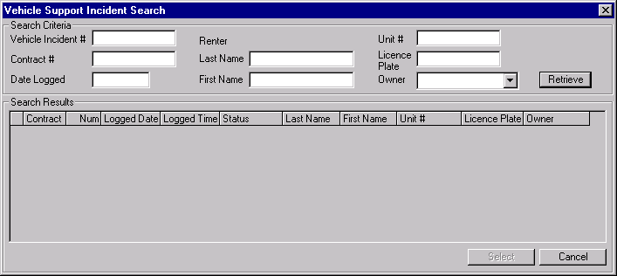
Purpose
The Vehicle Support Incident Search screen is used to identify a specific vehicle support incident.
This following search criteria are available. Only vehicle support incidents that meet all the criteria entered will be shown in the search results list.
- Vehicle Support Incident Sequence Number
- Contract Number
- Date Logged
- Renter Name
- Vehicle Unit Number and Vehicle Owner
- Vehicle Licence Plate and Vehicle Owner
A list of vehicle support incidents that match the search criteria will be presented in descending order by sequence number and the selected incident will be returned to the screen that opened the Vehicle Support Incident Search.
Navigation
Select: Returns the selected incident to the screen that opened this screen.
Functions
Retrieve: Finds all incidents that match the search criteria entered and uses them to populate the Search Results list.
Controls
Req*: Y – always mandatory
N – always optional
S – sometime optional (see Comments for details)
D – display only
Field | Source | Req* | Validation | Comments
Search Criteria
Vehicle Incident # | Vehicle Support Incident, Vehicle Support Incident Sequence | N | Numeric, whole number
Contract # | Vehicle Support Incident, Contract Number | N
Date Logged | Vehicle Support Incident, Logged On | N | Date | Date only, no time.
Renter Last Name | Vehicle Support Incident, Last Name | N
First Name | Vehicle Support Incident, First Name | N
Unit # | Vehicle Support Incident, Unit Number | N
Licence Plate | Vehicle Support Incident, Licence Plate | N
Vehicle Owner | Vehicle Support Incident, Owning Company | Y |  | Default is BRAC
Search Results
Contract | Vehicle Support Incident, Contract Number | D
Num | Vehicle Support Incident, Vehicle Support Incident Sequence | D
Logged Date, Logged Time | Vehicle Support Incident, Logged On | D
Status | Contract, Status | D |  | Will be blank if the vehicle support incident is for a foreign contract that is not recorded on GIS.
Last Name | Vehicle Support Incident, Last Name | D
First Name | Vehicle Support Incident, First Name | D
Unit # | Vehicle Support Incident, Unit Number | D
Licence Plate | Vehicle Support Incident, Licence Plate | D
Owner | Vehicle Support Incident, Owning Company | D

Contract Search Screen
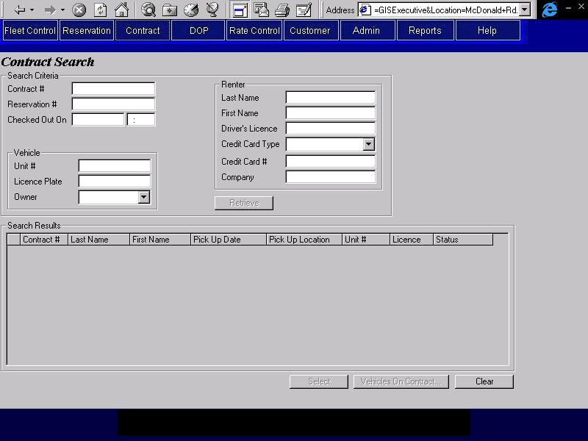
Purpose
This screen is used to search for contracts using any of the following search criteria. Only contracts that meet all the criteria entered will be shown in the search results list.
- Contract Number
- Reservation Number
- Checked Out On – date/time
Will limit the search to contracts that were checked out during the date and time specified. The Override Check In will be used for this, as well as Vehicle On Contract.
- Vehicle Unit Number
- Vehicle Licence Plate
Will return all contracts that had a vehicle on contract where the vehicle has this licence plate attached to it during the contract. If Checked Out On date/time is specified, will limit the search to the vehicle that the licence plate was attached to as of Checked Out On.
- Vehicle Owning Company
- Customer Name
- Driver Licence Number
- Credit Card
- Company Name
A list of contracts that match the search criteria will be presented in descending order by pick up date. If the search screen was opened from another contract screen, the selected contract will be returned to the screen that opened the Contract Search. If the search screen was opened from the menu, the selected contract number will be saved in an internal GIS Selected Contract registry. It will be used to trigger an automatic Retrieve the next time a contract screen is opened, or as the default contract # the next time Retrieve is used in a contract screen that is already open, whichever comes first.
Screen Hierarchy

See the screen hierarchy diagrams for Contract Open/Check Out, Changes During Rental, Check In and Adjustments.
Navigation
Select: Returns the selected contract to the screen that opened the Contract Search screen (if any) or saves the contract number in an internal GIS Selected Contract registry if the search screen was opened from the menu. The status of the selected contract must match the screen that opened the Contract Search screen (if any). As follows:
Screen Contract Status
Contract Open/Check Out Open
Changes During Rental Checked Out
Check In Checked Out
Adjustments Checked In, Closed
Vehicles on Opens the Vehicle On Contract Search screen populated with the vehicles on
Contract: contract for the selected contract.
Functions
Retrieve: Finds all contracts that match the search criteria entered and uses them to populate the Search Results list.
Controls
Req*: Y – always mandatory
N – always optional
S – sometime optional (see Comments for details)
D – display only
Field | Source | Req* | Validation | Comments
Search Criteria
Contract # | Contract, Contract Number | N
Reservation # | Contract, Confirmation Number | N
Checked Out On | Vehicle On Contract, Check Out and Actual Check In | N | Date and time | Where Checked Out On >= Vehicle On Contract, Check Out and Checked Out On <= Vehicle On Contract, Actual Check In (or Expected Check In if Actual Check in is null)
Unit # | Vehicle On Contract, Unit Number | N
Licence Plate | Vehicle Licence History, Licence Plate Number | N |  | If Check Out On date is entered, use this date to determine which vehicle the licence was attached to. Otherwise return all vehicles that the licence plate was attached to.
Vehicle Owner | Vehicle, Vehicle Owning Company | S |  | Required if Unit # or Licence Plate is entered  Default is BRAC if either of these fields are entered and null otherwise
Renter Last Name | Contract, Last Name | N
First Name | Contract, First Name | N
Driver’s Licence | Renter Driver Licence, Number | N
Credit Card Type | Credit Card, Credit Card Type ID | N | Value controlled by Credit Card Type table. | From Credit Card Payment, Credit Card Authorization, or Renter Primary Billing.
Credit Card Number | Credit Card, Credit Card Number | N |  | From Credit Card Payment, Credit Card Authorization, or Renter Primary Billing.
Company | Contract, Company Name | N
Search Results
Contract # | Contract, Contract Number | D
Last Name | Contract, Last Name | D
First Name | Contract, First Name | D
Pick Up Date | Contract, Pick Up On | D
Pick Up Location | Contact, Pick Up Location ID | D |  | Display Location name.
Unit # | Vehicle On Contract, Unit Number | D |  | For most recent Vehicle On Contract.
Licence | Vehicle Licence History, Licence Plate Number | D |  | For most recent Vehicle On Contract.  Display licence number that was attached to the vehicle at the time of vehicle check out.
Status | Contract, Status | D

Vehicle on Contract Search Screen
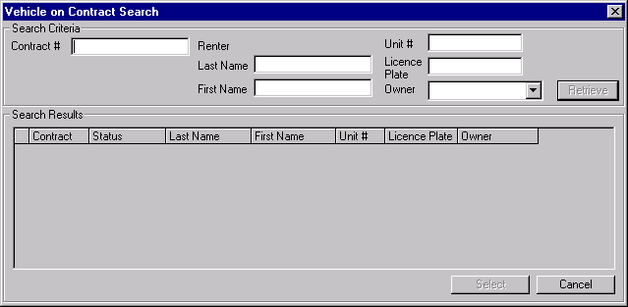
Purpose
The Vehicle on Contract Search screen is used to identify a specific contract and one of the vehicles checked out on it. It is used by Vehicle Support.
The following search criteria are available. Only vehicles on contract that meet all the criteria entered will be shown in the search results list (in descending order by contract pick up date and vehicle on contract check out date).
- Contract #
  - If the contract exists on GIS, a list of the vehicles checked out on the contract will be presented.
  - If the contract does not exist on GIS, a message will be displayed.
- Renter Last Name (and First Name if available)
A list of all contracts for that name, and the vehicles checked out on them will be presented
- Unit # and Vehicle Owner
  - If a vehicle for the unit # and vehicle owner exists on GIS, a list of contracts for the vehicle will be presented.
  - If a vehicle for the unit # and vehicle owner does not exist on GIS, a message will be displayed.
- Licence Plate and Vehicle Owner
  - If a vehicle for the licence plate and vehicle owner exists on GIS, a list of contracts for the vehicle will be presented.
  - If a vehicle for the licence plate and vehicle owner does not exist on GIS, a message will be displayed.
Navigation
Select: If opened from the Vehicle Support screen and the selected vehicle on contract is not checked in yet, returns to the Vehicle Support Incident screen with the selected vehicle on contract.
Functions
Retrieve: Finds all vehicles on contract that match the search criteria entered and uses them to populate the Search Results list.
Controls
Req*: Y – always mandatory
N – always optional
S – sometime optional (see Comments for details)
D – display only
Field | Source | Req* | Validation | Comments
Search Criteria
Contract # | Vehicle On Contract, Contract Number | N
Renter Last Name | Contract, Last Name | N
First Name | Contract, First Name | N
Unit # | Vehicle On Contract, Unit Number | N
Licence Plate | Vehicle, Current Licence Plate | N
Owner | Contract, Vehicle Owning Company | Y |  | Default is BRAC
Search Results
Contract | Vehicle On Contract, Contract Number | D
Status | Contract, Status | D
Last Name | Contract, Last Name | D
First Name | Contract, First Name | D
Unit # | Vehicle On Contract, Unit Number | D
Licence Plate | Vehicle, Current Licence Plate | D
Owner | Vehicle, Vehicle Owning Company | D

Reports

All the vehicle support reports are defined in the GIS Reports business design documents.

Tables without Maintenance Screens
This section is superseded by the Production System Maintained Tables document.
- Type of Incident
- Mechanical
- Damage
- Stolen
- Seizure
- Type of Mechanical Problem
- Key locked inside vehicle with engine running
- Key locked inside vehicle
- Key locked in trunk
- Lost key
- Flat tire
- Dead Battery
- Engine won’t start
- Locked steering
- Gear shift will not engage
- Other
- Type of Damage Problem
- Undercarriage damage (i.e. leaking oil)
- Accident
- Broken window
- Break and enter
- Vehicle rolled
- Other

Data Model
See the Budget ER1 logical data model.

Revision History

Version 2.00
- Clean up documentation and make consistent with the GIS standards.

